Project Documentation
Results: Output Screenshots
System UI > UI Policies > New. Table = Incident, Short description = High Impact Control, condition Impact is 1 - High, Reverse if false enabled.
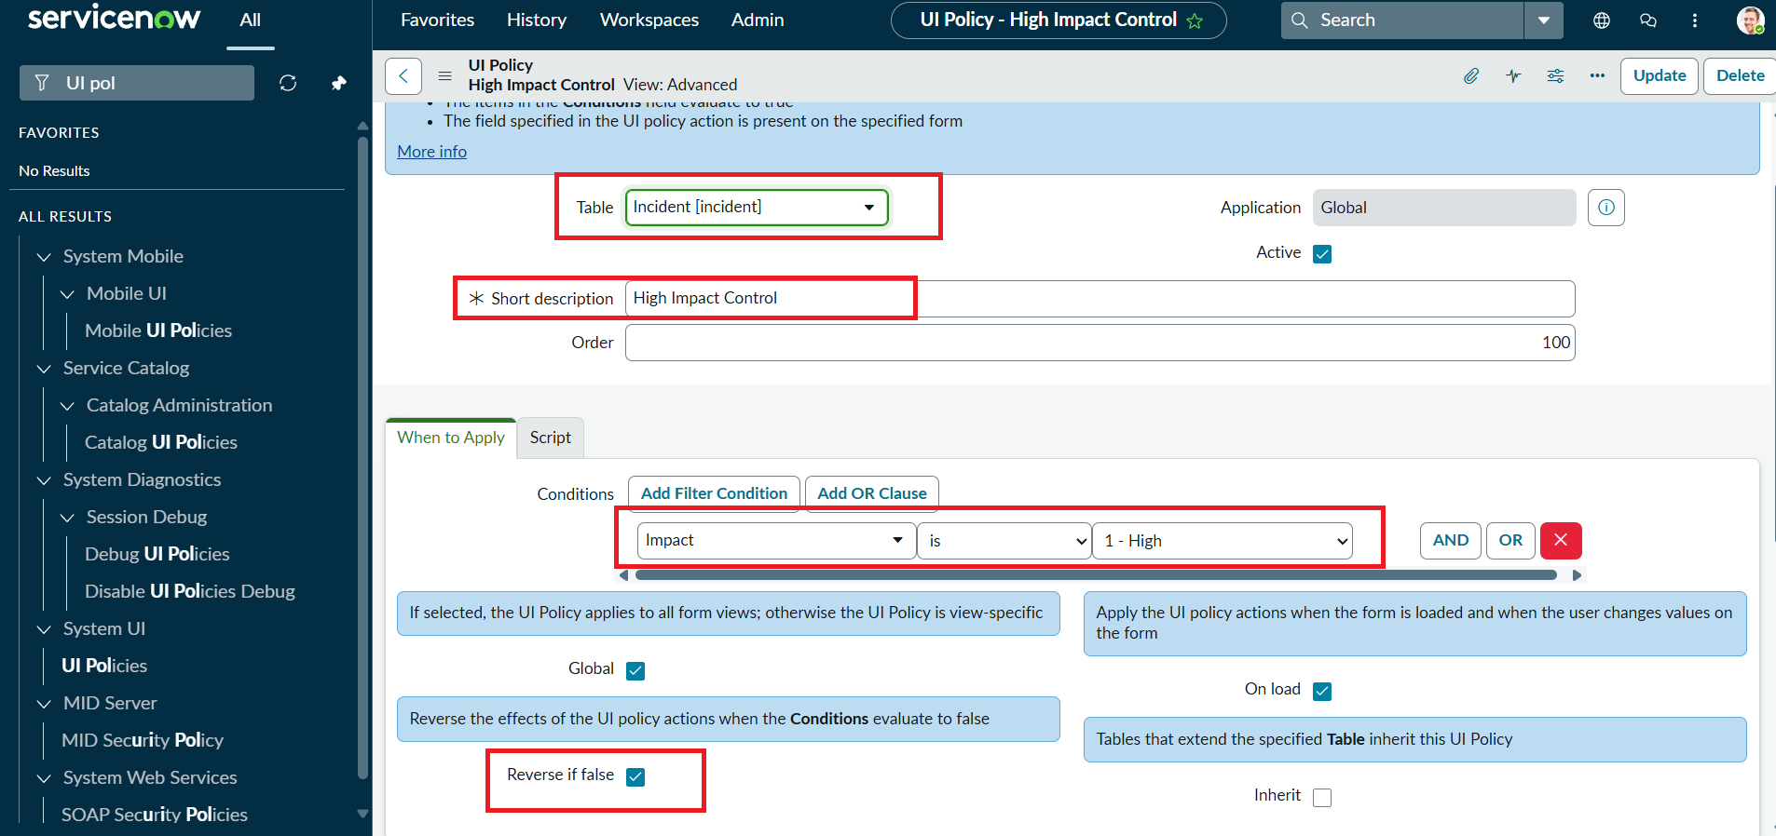
Figure 1: UI Policy configuration (Incident, Impact is 1 - High, Reverse if false)
UI Policy Action on Assignment group: Mandatory = True, Read only = False.
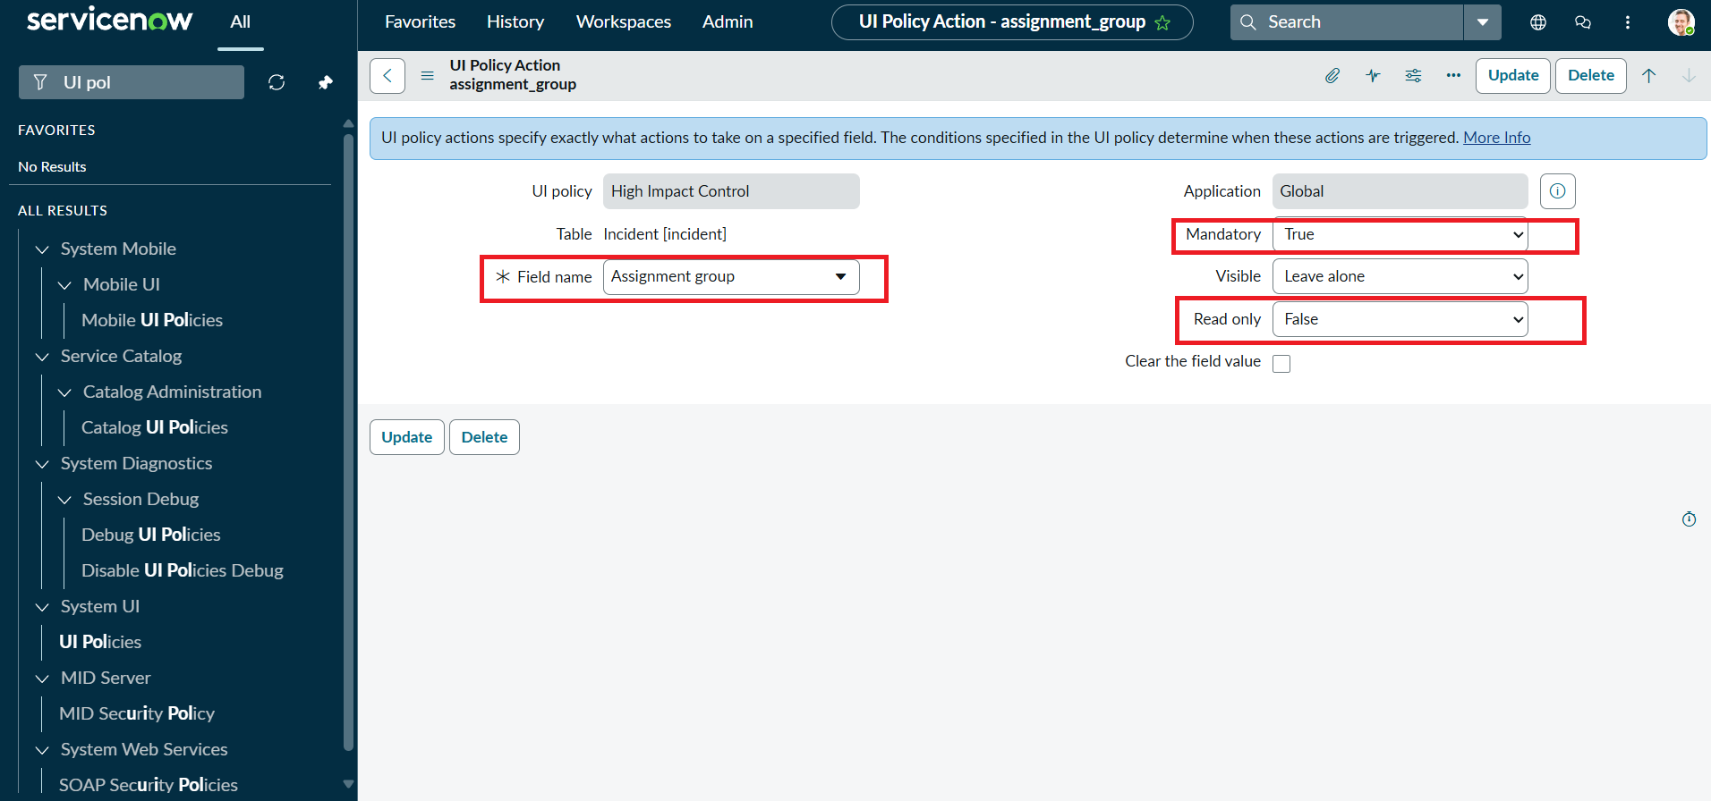
Figure 2: UI Policy Action - Assignment group mandatory

Task 2: UI Policy Action - Urgency
Urgency is read-only whenever Impact is High; Visible is left unchanged.
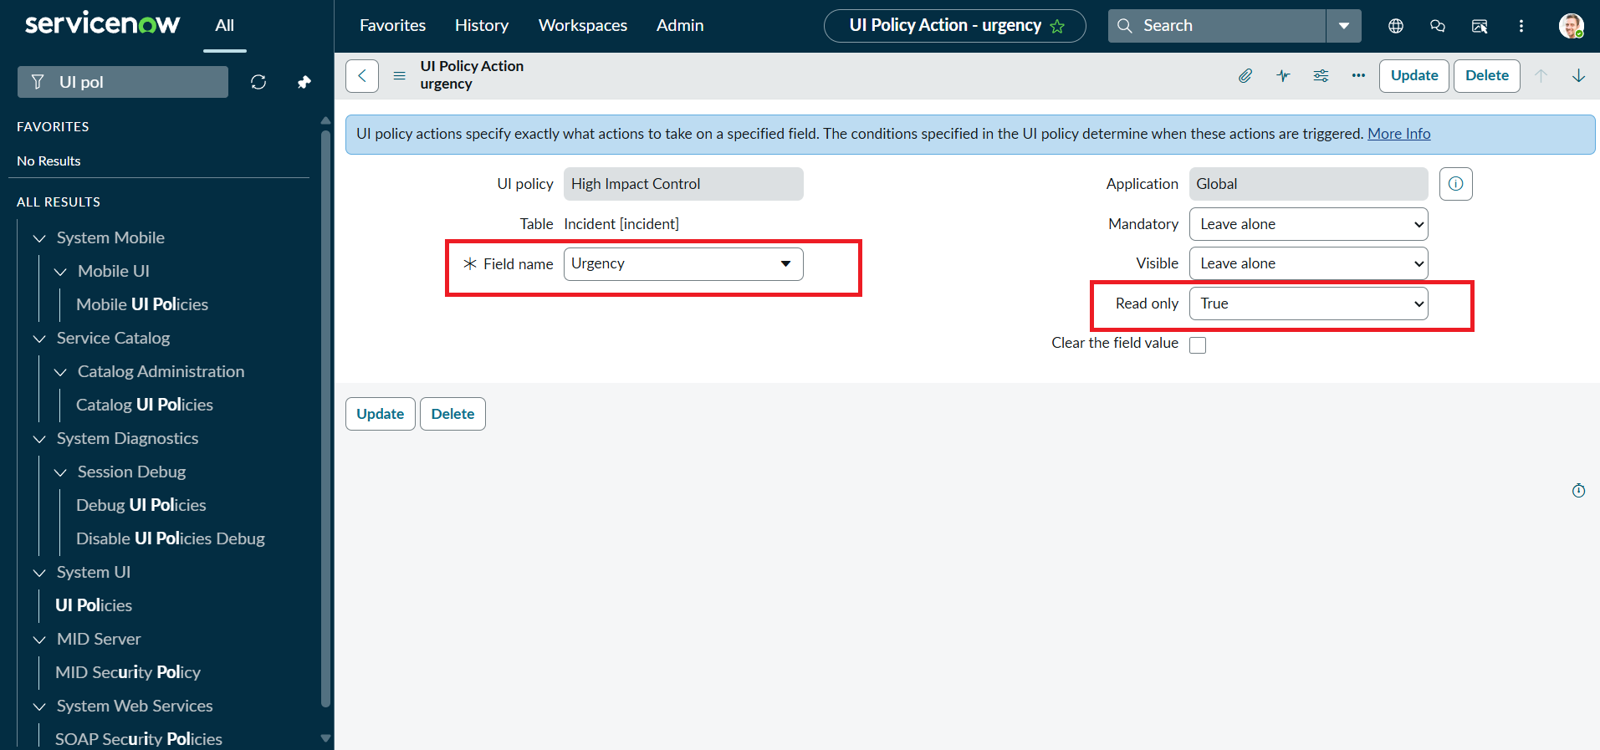
Figure 3: UI Policy Action - Urgency read-only

Task 3: onChange Client Script - Auto set urgency for high impact
Type onChange, Field name Impact, Table Incident. Script as specified in the project instructions:
function onChange(control, oldValue, newValue, isLoading) {
if (isLoading || newValue == '') {
return;
}
if (newValue == '1') {
g_form.setValue('urgency', '1');
g_form.addInfoMessage('Urgency set to High for High impact incident.');
}
}
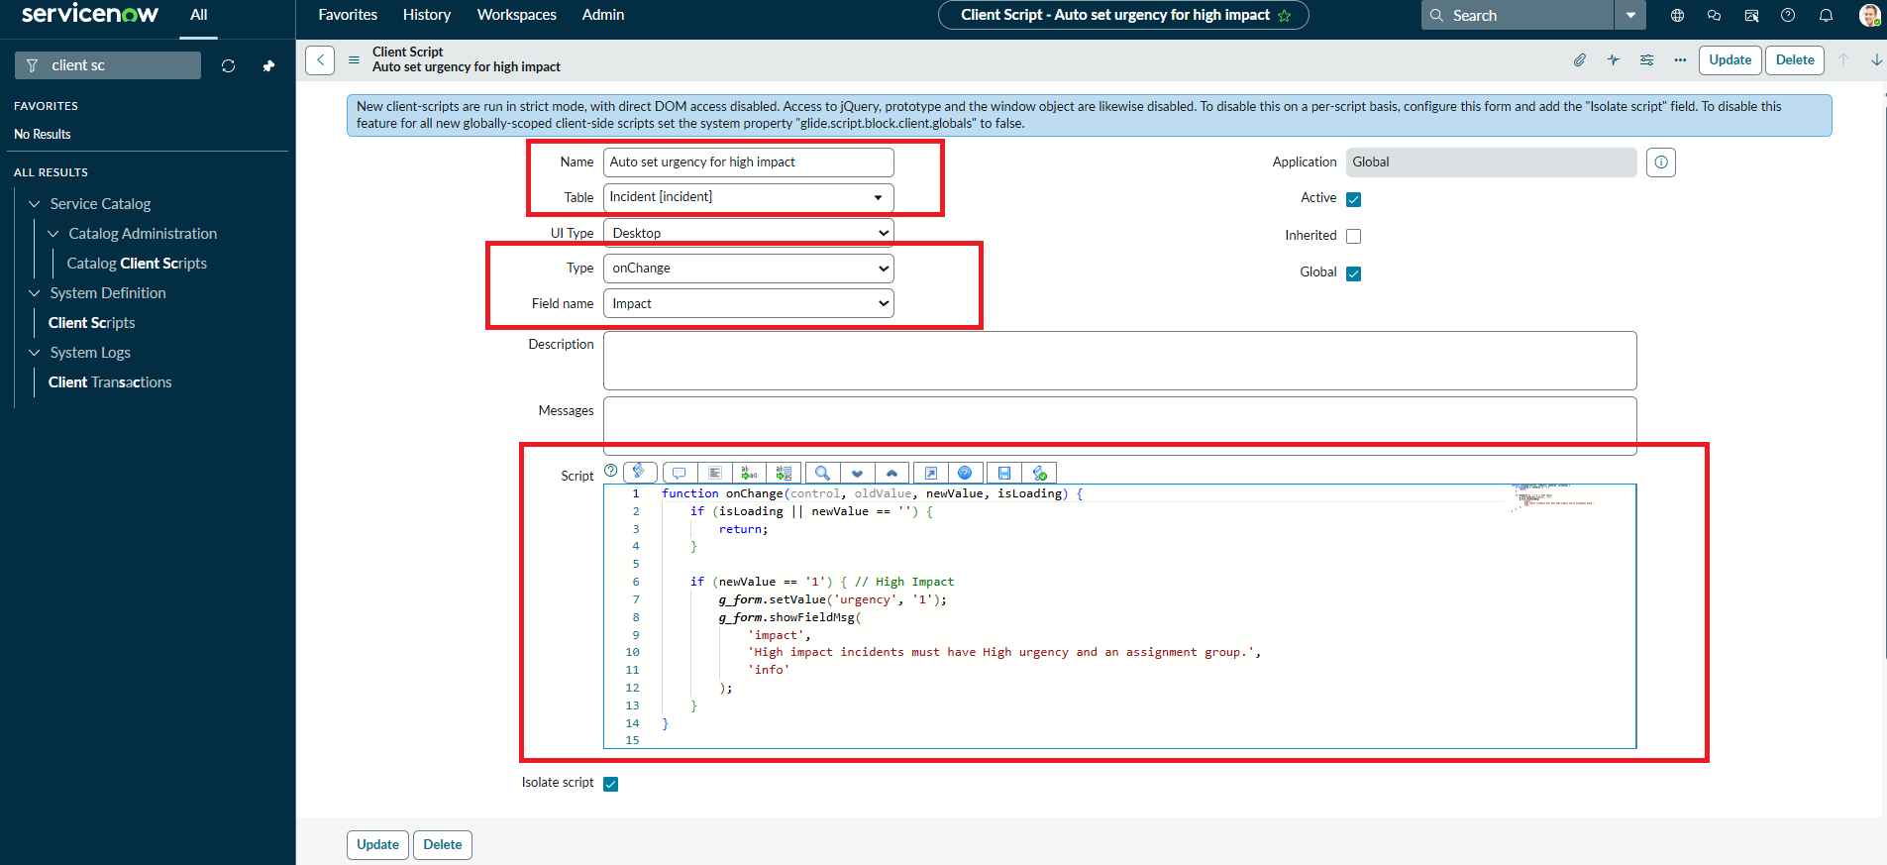
Figure 4: onChange Client Script configuration

Task 4: onSubmit Client Script - Prevent save if Assigned To missing
function onSubmit() {
if (g_form.getValue('impact') == '1' &&
g_form.getValue('assigned_to') == '') {
g_form.showErrorBox(
'assigned_to',
'Assigned To is mandatory for High impact incidents.'
);
return false;
}
return true;
}
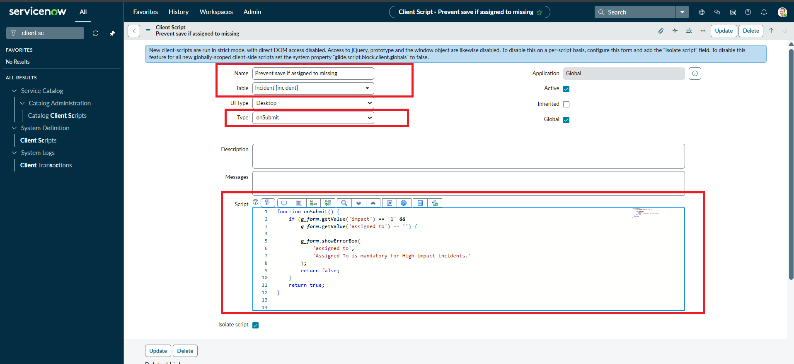
Figure 5: onSubmit Client Script configuration

Task 5: onCellEdit Client Script - Prevent state change via list edit
function onCellEdit(sysIDs, table, oldValues, newValue, callback) {
alert('State cannot be updated using list editing. Please open the Incident.');
callback(false);
}
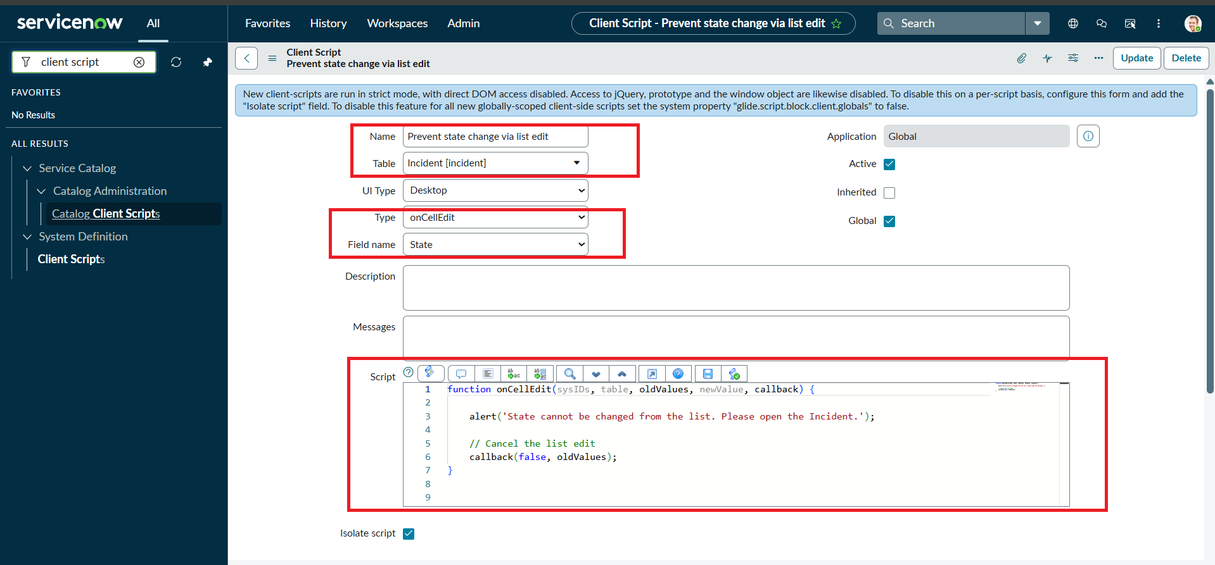
Figure 6: onCellEdit Client Script configuration (Field name: State)

Task 6: Testing the Configuration
Activity 1 - Mandatory enforcement: Impact set to High and Assigned To left empty. Submit is blocked and an error appears under Assigned To.
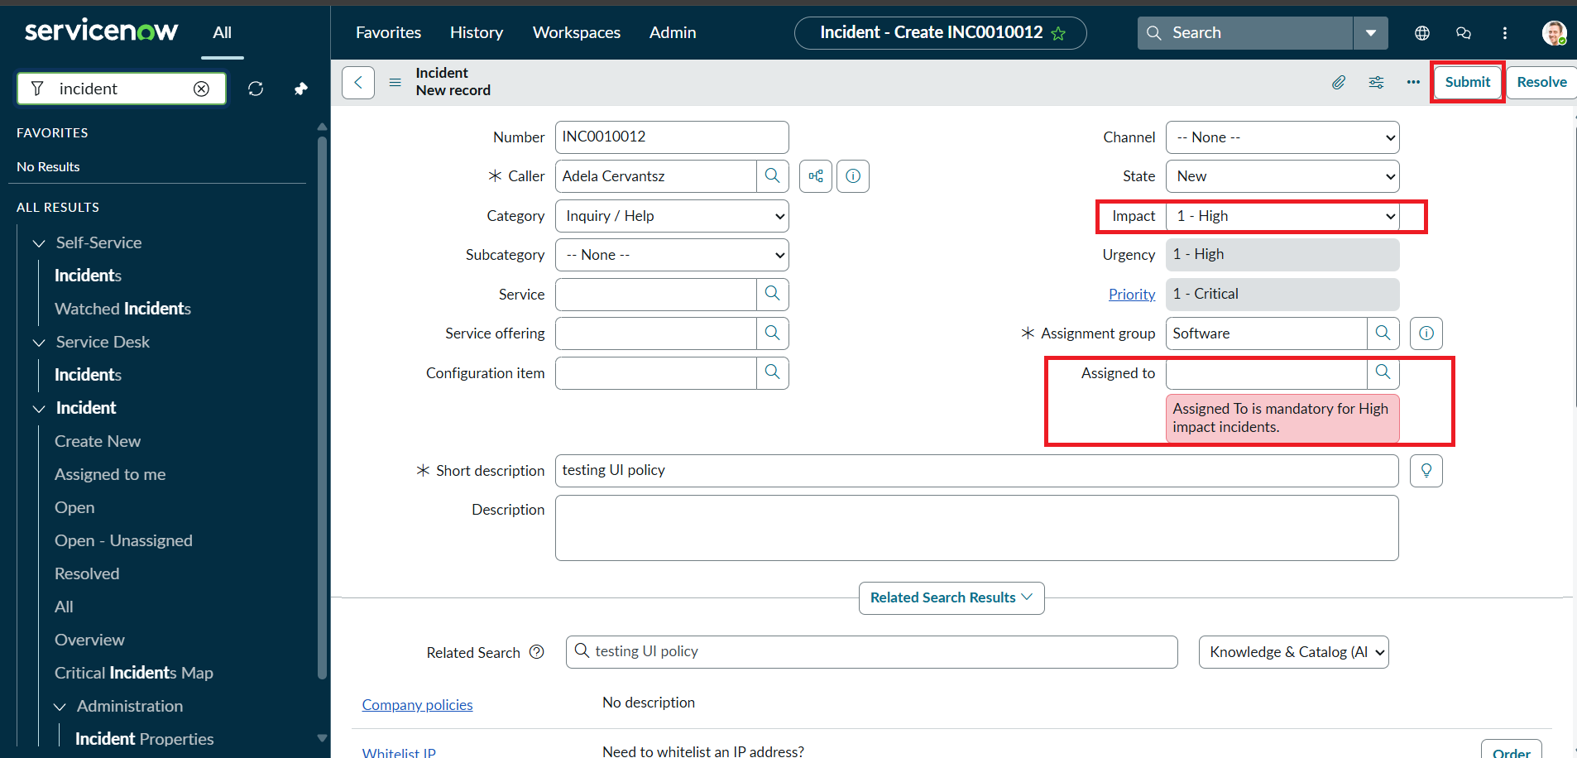
Figure 7: Save blocked with error message on Assigned To
Activity 2 - Successful save: with Assigned To filled, the Incident saves; Urgency is 1 - High and read-only.
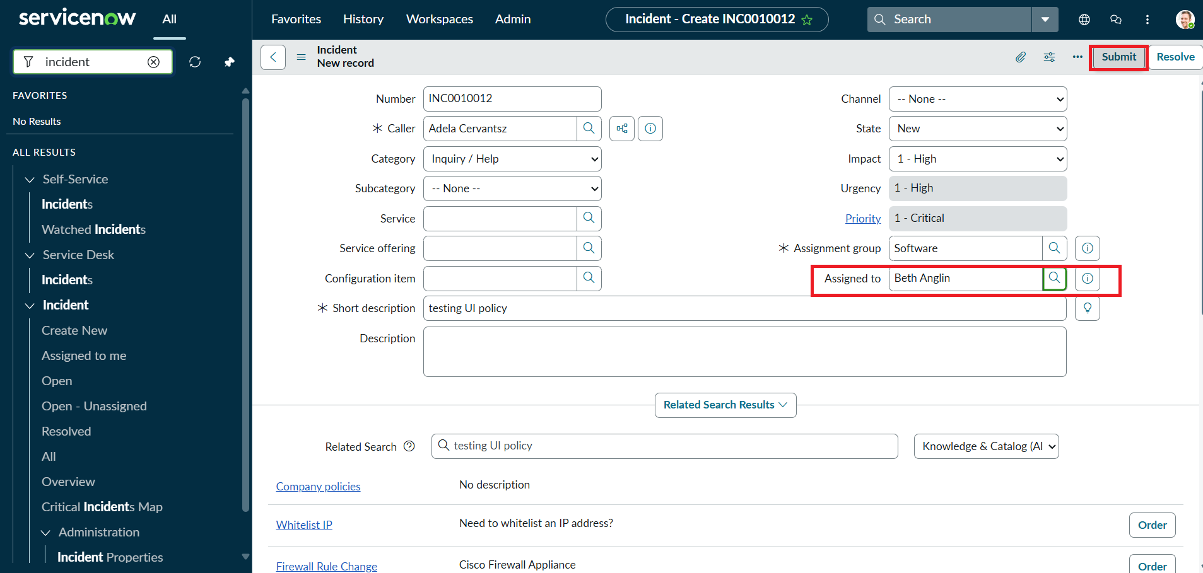
Figure 8: Incident with Assigned To populated, Urgency read-only
Activity 3 - Reverse condition: Impact changed to 2 - Medium; Assigned To is no longer required.
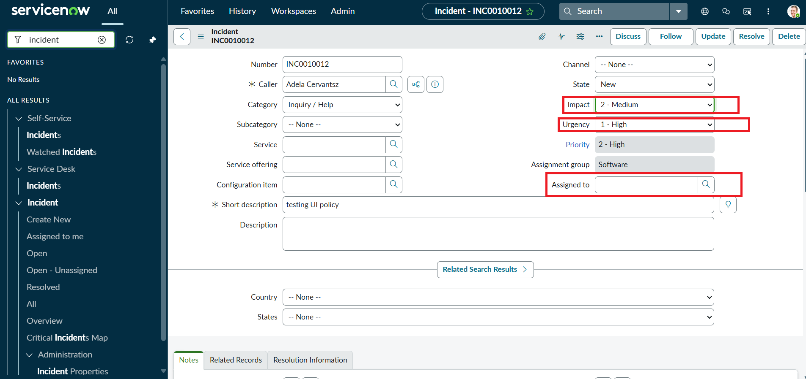
Figure 9: Reverse-if-false behaviour after changing Impact to Medium
Activity 4 - List edit blocking: editing State from the list shows an alert and leaves the value unchanged.
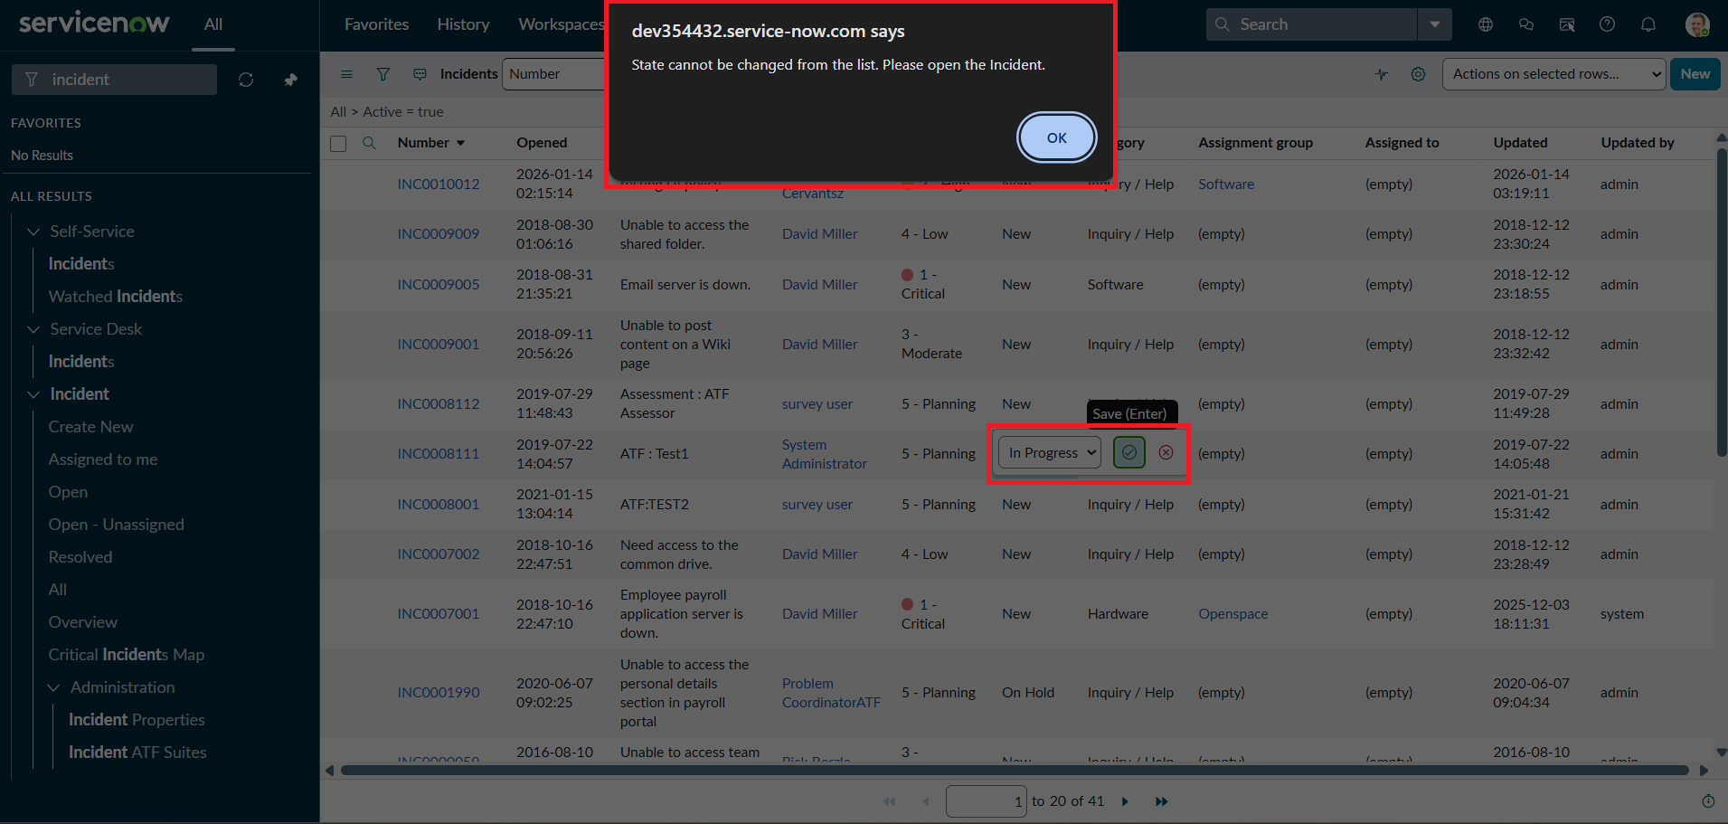
Figure 10: Alert shown when editing State in list view
Activity 5 - Form-based update: State changed to In Progress on the form and saved successfully.
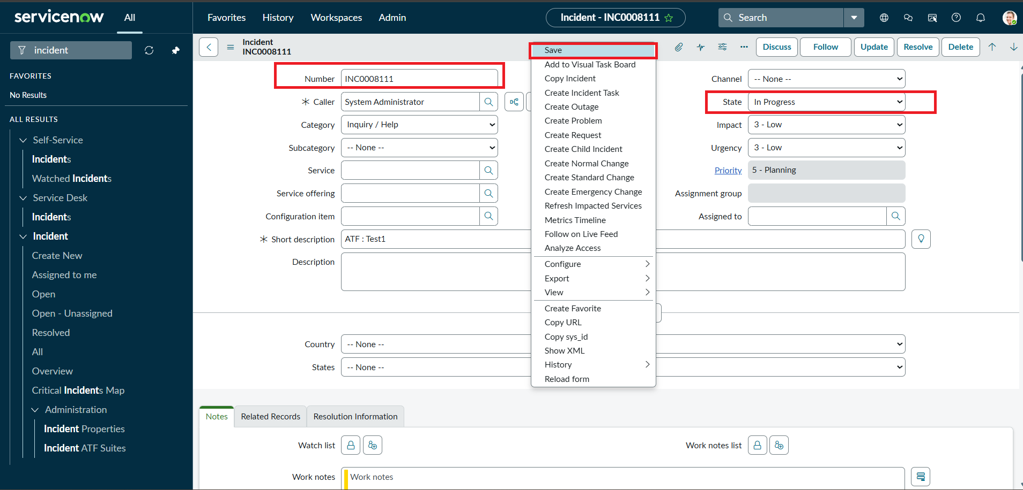
Figure 11: State updated on the Incident form
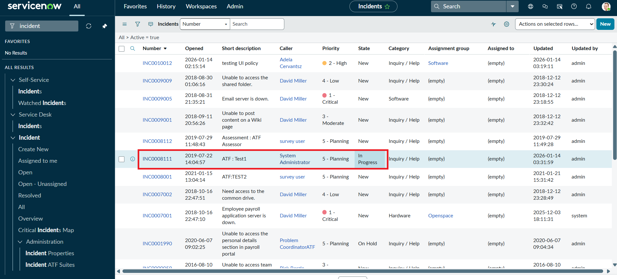
Figure 12: Incident list showing the updated State (In Progress)

